Exercise 9

1. Now we have icons of six famous IT companies ("microsoft", "google", "yahoo", "facebook", "ibm", and "apple"). Please develop a webpage to make a slideshow that **randomly displays a photo per second**.

  



Hint:

Use setInterval() to show a new photo per second.

1. Please develop a note application:
2. The initial UI is shown as follows:

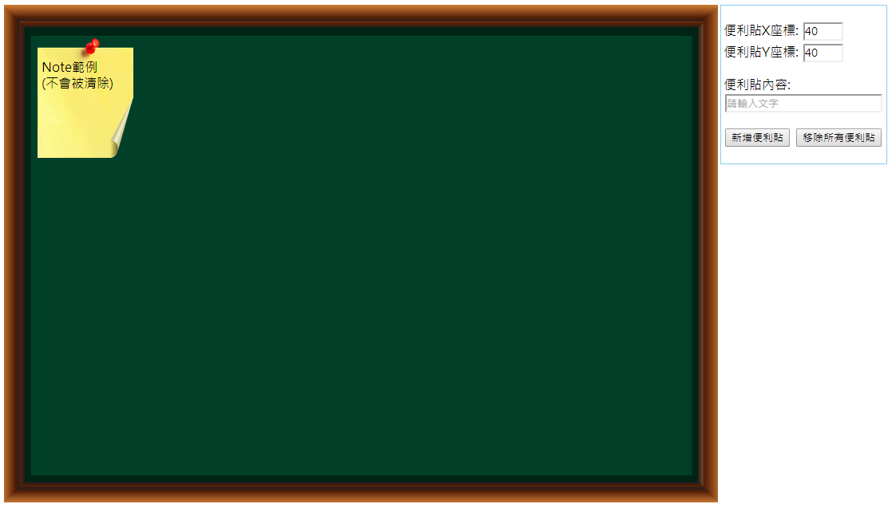

1. The user can input the coordinate of X and Y, fill out the note content, and click the button "新增便利貼". A corresponding note will appear in the blackboard.

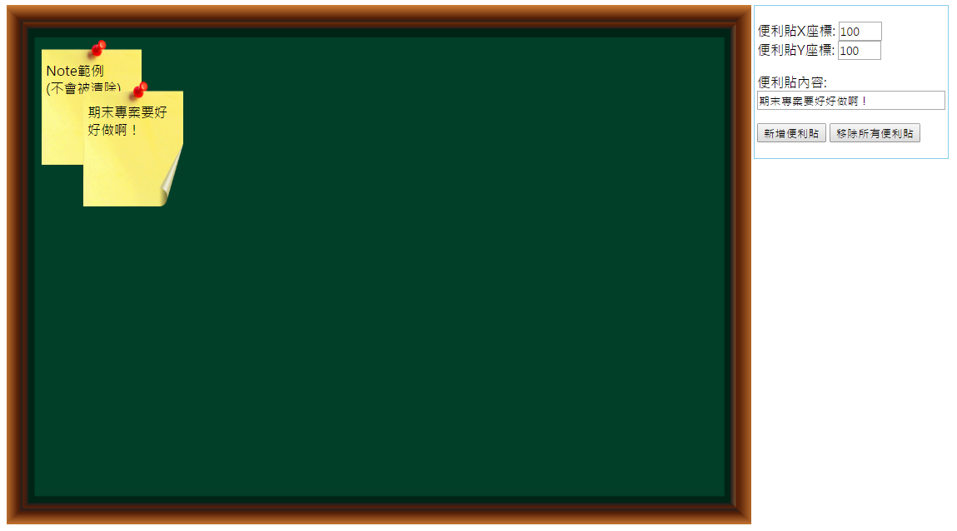

1. When the user clicks the button "移除所有便利貼", all notes will be removed.

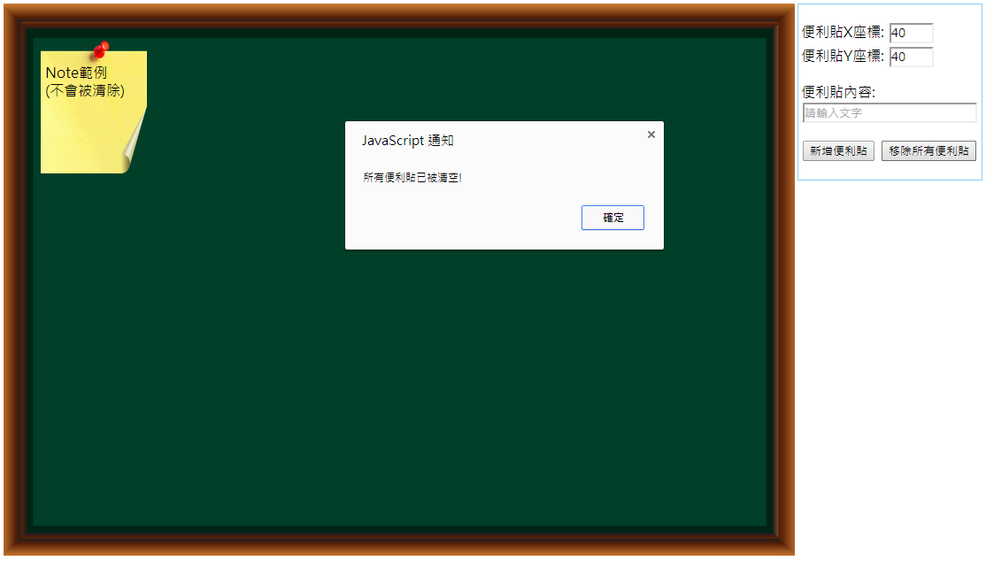

1. Bonus: when the user closes the browser and re-opens the browser, all previous notes can still show in the blackboard.

Hint:

1. 本題提供HTML與CSS檔內容，但可依個人偏好修改。
2. 請務必先理解目前HTML與CSS之寫法，再下手寫JavaScript。
3. 新增與移除DOM node之方法可參考課本範例12_03。
4. 目前已設定"position: absolute"，可再用top與left屬性來設定位置。
5. 請運用圖層屬性z-index，讓後來加入的note顯示於上方。
6. 請參考課本範例11_17瞭解如何使用web storage，但要特別設計key和value之資料格式。